**Question 1: String Operations                                                                              20**

**Write a Python script that performs the following:**

* Takes a string input from the user.
* Reverses the string and prints the result.
* Converts the string to uppercase and lowercase.
* Counts the number of vowels in the string.

**Deliverable:**Submit the Python script and a screenshot of the output.

**Solution:-**

**Python script:**

# Take input from the user

user_input = input("Enter a string: ")

# Reverse the string

reversed_string = user_input[::-1]

print("Reversed String:", reversed_string)

# Convert to uppercase

uppercase_string = user_input.upper()

print("Uppercase String:", uppercase_string)

# Convert to lowercase

lowercase_string = user_input.lower()

print("Lowercase String:", lowercase_string)

# Count the number of vowels

vowels = "aeiouAEIOU"

vowel_count = sum(1 for char in user_input if char in vowels)

print("Number of vowels:", vowel_count)

**Output:**

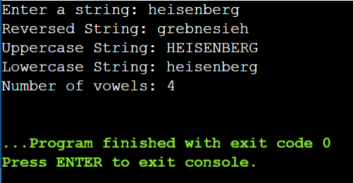

**Question 2: List and Tuple Operations                                                               20**

Write a Python program to solve the following:

* Take a list of integers as input from the user.
* Find and print the largest and smallest numbers in the list.
* Convert the list into a tuple and display it.
* Access and print the third element of the tuple.

**Deliverable:**  
Submit the Python script and screenshots of outputs.

**Solution:-**

**Python script:**

# Take a list of integers as input from the user

num_list = list(map(int, input("Enter a list of integers separated by spaces: ").split()))

# Find and print the largest and smallest numbers in the list

largest_num = max(num_list)

smallest_num = min(num_list)

print("Largest number:", largest_num)

print("Smallest number:", smallest_num)

# Convert the list into a tuple and display it

num_tuple = tuple(num_list)

print("Tuple:", num_tuple)

# Access and print the third element of the tuple (if it exists)

if len(num_tuple) >= 3:

print("Third element of the tuple:", num_tuple[2])

else:

print("The tuple does not have a third element.")

**Output:**

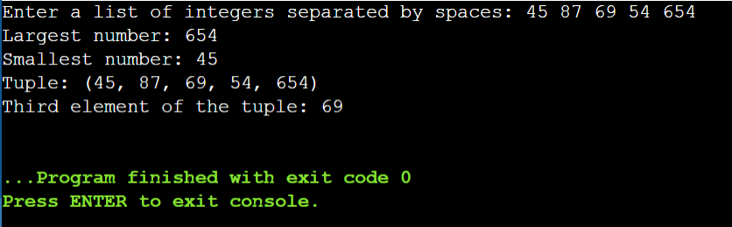

**Question 3: Tic-Tac-Toe Mini-Game                                                                   30**

Write a Python program to implement a simple two-player Tic-Tac-Toe game:

* Use a 3x3 grid represented by a list of lists.
* Allow players to take turns, entering their moves.
* Check for a winner after each move or a tie if the board is full.

**Deliverable:**Submit Python scripts for both games and screenshots of gameplay results.

**Solution:-**

**Python script:**

def print_board(board):

for row in board:

print(" | ".join(row))

print("-" * 9)

def check_winner(board, player):

# Check rows and columns

for i in range(3):

if all(board[i][j] == player for j in range(3)) or all(board[j][i] == player for j in range(3)):

return True

# Check diagonals

if all(board[i][i] == player for i in range(3)) or all(board[i][2 - i] == player for i in range(3)):

return True

return False

def is_full(board):

return all(cell in ['Dipon', 'Opponent'] for row in board for cell in row)

def tic_tac_toe():

board = [[' ' for _ in range(3)] for _ in range(3)]

players = ['Dipon', 'Opponent']

turn = 0

while True:

print_board(board)

row, col = map(int, input(f"Player {players[turn % 2]}, enter row and column (0-2): ").split())

if board[row][col] == ' ':

board[row][col] = players[turn % 2]

if check_winner(board, players[turn % 2]):

print_board(board)

print(f"Player {players[turn % 2]} wins!")

break

if is_full(board):

print_board(board)

print("It's a tie!")

break

turn += 1

else:

print("Invalid move, try again.")

if __name__ == "__main__":

tic_tac_toe()

**Output:**

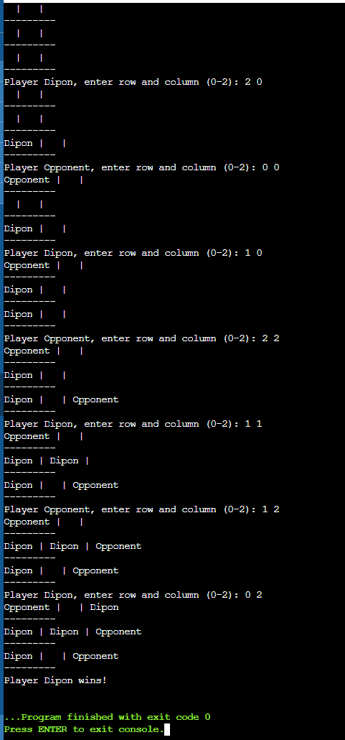

**Question 4: Rock-Paper-Scissors Mini-Game                                                    30**

Write a Python program for a Rock-Paper-Scissors game:

* Allow a user to play against the computer.
* Use random to generate the computer's choice.
* Compare the user’s and computer’s choices to determine the winner or if it’s a draw.
* Announce the result at the end of each round.

**Deliverable:**Submit Python scripts for both games and screenshots of gameplay results.

**Solution:-**

**Python script:**

import random

def get_computer_choice():

return random.choice(["rock", "paper", "scissors"])

def get_user_choice():

while True:

choice = input("Enter rock, paper, or scissors: ").strip().lower()

if choice in ["rock", "paper", "scissors"]:

return choice

print("Invalid choice, please try again.")

def determine_winner(user, computer):

if user == computer:

return "It's a draw!"

elif (user == "rock" and computer == "scissors") or \

(user == "scissors" and computer == "paper") or \

(user == "paper" and computer == "rock"):

return "You win!"

else:

return "Computer wins!"

def play_game():

user_choice = get_user_choice()

computer_choice = get_computer_choice()

print(f"Computer chose: {computer_choice}")

print(determine_winner(user_choice, computer_choice))

if __name__ == "__main__":

play_game()

**Output:**

